# **BOOKS SALES QUERIES(P1)**

* **BASIC QUERIES :**

**1). Retrieve all books in the "Fiction" genre ?**

SELECT title,Author,genre FROM Books

where Genre='Fiction';

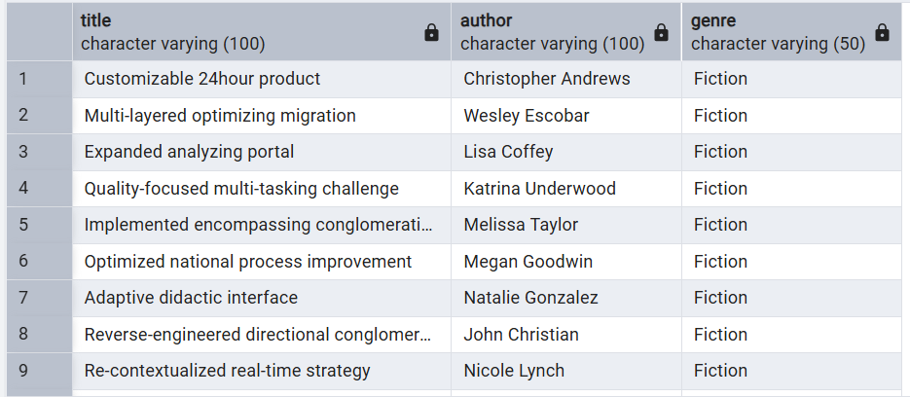

**2). Find books published after the year 1950 ?**

SELECT title,author,published_year FROM Books

where published_year>1950;

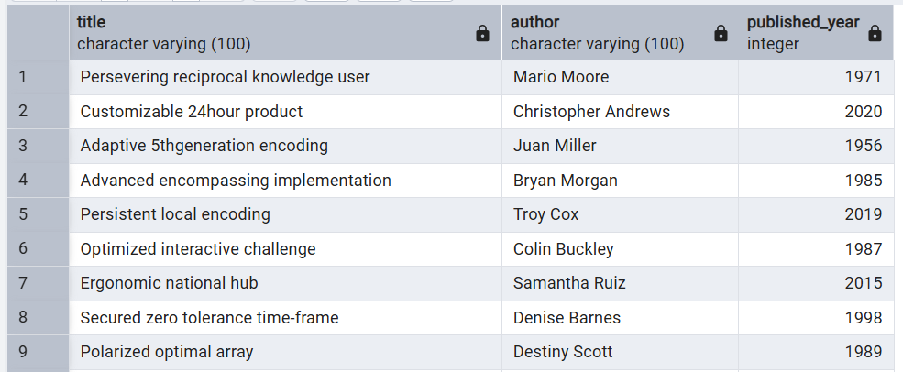

**3). List all customers from the Canada ?**

SELECT name,city,country FROM Customers

where country='Canada';

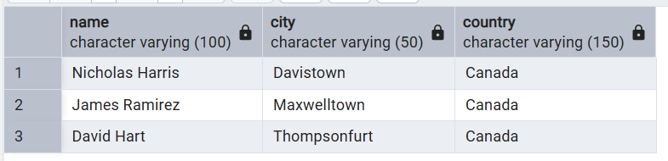

**4). Show orders placed in November 2023 ?**

SELECT * FROM Orders

where order_date between '2023-11-01' AND '2023-11-30';

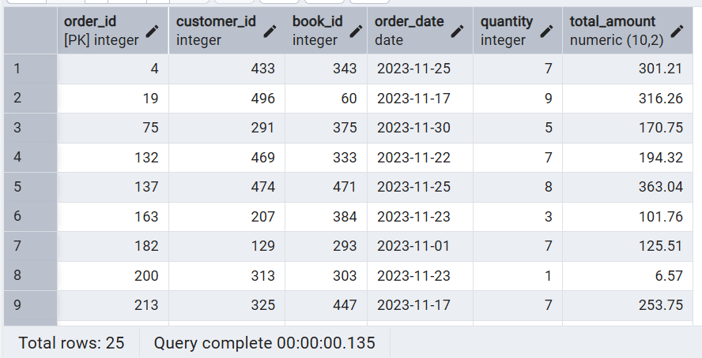

**5). Retrieve the total stock of books available ?**

SELECT sum(stock)

from Books;

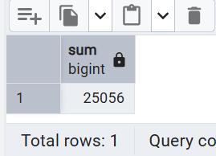1

**6). Find the details of the most expensive book ?**

SELECT title,author,price FROM Books

order by price desc

limit 5;

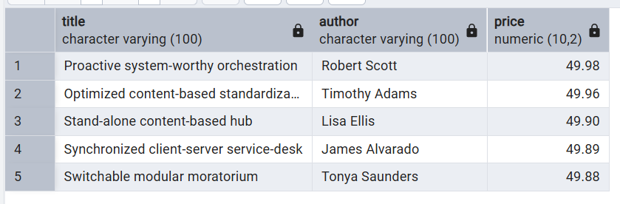

**7). Show all customers who ordered more than 1 quantity of a book ?**

SELECT * FROM Orders

where quantity>1;

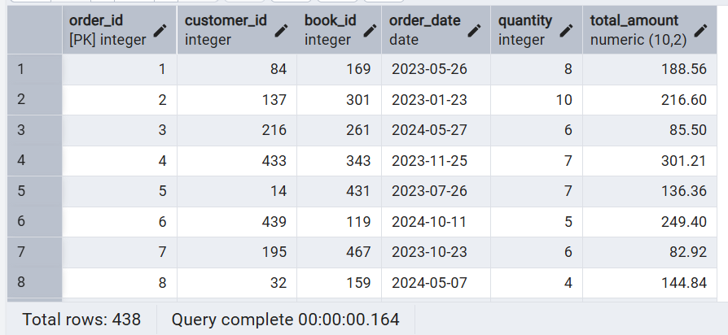

**8). Retrieve all orders where the total amount exceeds $20?**

SELECT * FROM Orders

where total_amount>20;

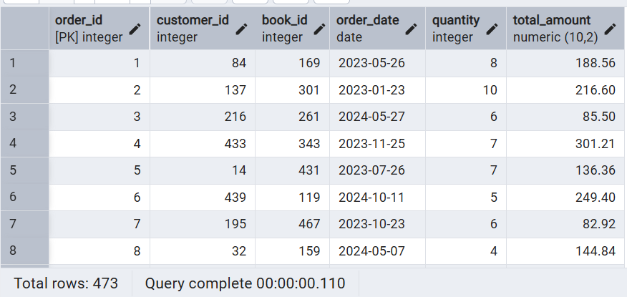

**9). List all genres available in the Books table ?**

SELECT distinct genre FROM Books;

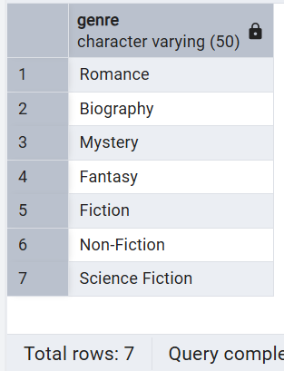

**10). Find the book with the lowest stock ?**

SELECT title,author,price,stock FROM Books

order by stock asc

limit 5;

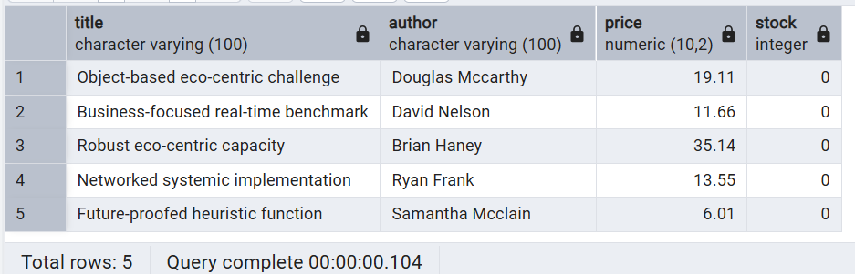

**11). Calculate the total revenue generated from all orders ?**

SELECT sum(total_amount) as total_Revenue

FROM Orders;

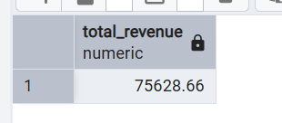

SELECT * FROM Books;

SELECT * FROM Customers;

SELECT * FROM Orders;

* **Advance Questions :**

**1). Retrieve the total number of books sold for each genre ?**

select b.genre,sum(o.quantity) as Sum_Total

from Orders O

join

Books B on b.book_id=o.book_id

group by b.genre;

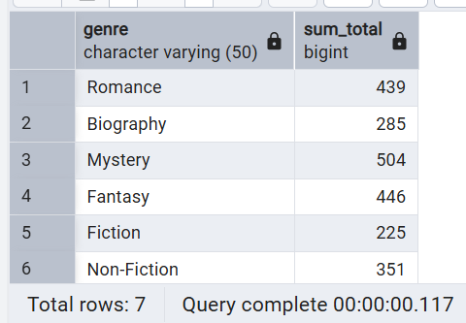

**2). Find the average price of books in the "Fantasy" genre ?**

select avg(price)

from books

where genre='Fantasy';

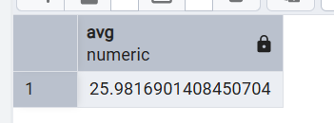

**3). List customers who have placed at least 2 orders ?**

select c.name,count(o.customer_id) as least_orders

from customers c

join orders o on c.customer_id=o.customer_id

group by c.name

having count(o.customer_id)>=2;

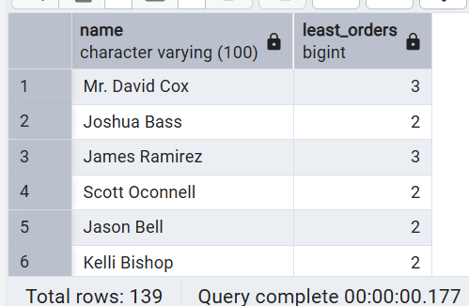

**4). Find the most frequently ordered book ?**

select o.book_id,b.title,count(o.order_id) as most_ordered_book

from books b

join orders o on b.book_id=o.book_id

group by o.book_id,b.title

order by most_ordered_book desc

limit 1;

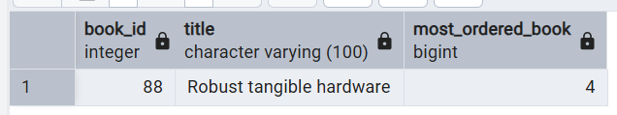

**5). Show the top 3 most expensive books of 'Fantasy' Genre ?**

select title,genre,price

from books

where genre='Fantasy'

order by price desc

limit 3;

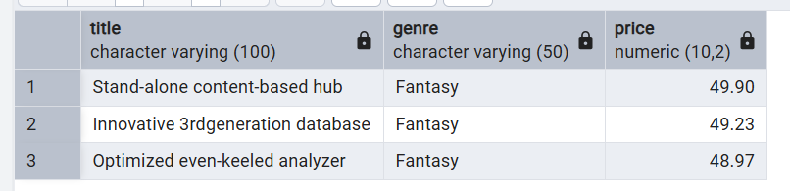

**6). Retrieve the total quantity of books sold by each author ?**

select b.author,sum(o.quantity) as total_books_soled

from books b join orders o on b.book_id=o.book_id

group by b.author

order by total_books_soled desc

limit 5;

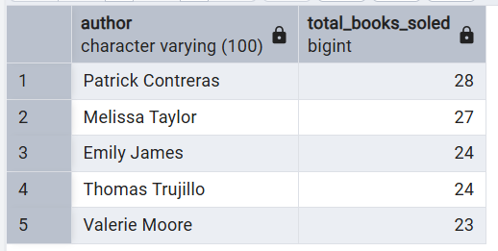

**7). List the cities where customers who spent over $30 are located ?**

select distinct c.city,o.total_amount

from customers c

join orders o on c.customer_id=o.customer_id

where o.total_amount>30;

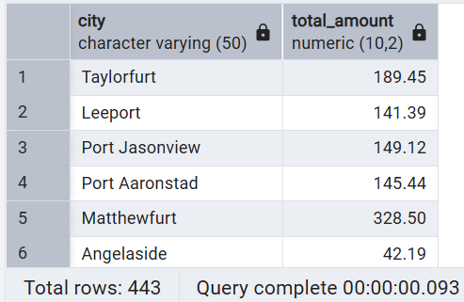

**8). Find the customer who spent the most on orders ?**

select c.name,sum(o.total_amount) as sum_of_spend

from customers c

join orders o on c.customer_id=o.customer_id

group by c.name

order by sum_of_spend desc

limit 5;

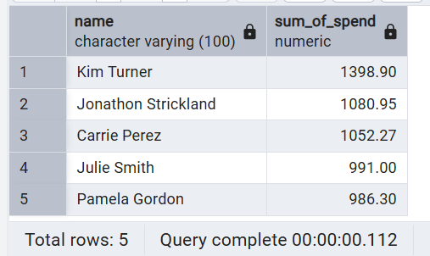

**9). Calculate the stock remaining after fulfilling all orders?**

select b.book_id,b.title,b.stock,coalesce(sum(quantity),0) as total_books_soled,

b.stock-coalesce(sum(quantity),0)

from books b

left join orders o on b.book_id=o.book_id

group by b.book_id;

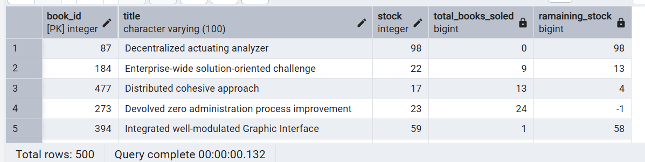

* **KEY INSIGHTS :**
* 75,628 Rupees Is The Total Revenue Generated From All Books.
* 25056 Rupees Is The Total Stock Available For The Books.
* 49.98 Rupees Is The Most Expensive Book.
* 7 Types Books : Romance, Biography, Mystry, Fanstasy, Fiction, Non_Fiction, Science Fiction.
* Romance Is The Top Sold Book of 439.
* There Are 139 Customer Who Placed 2 Orders & Than 2 Orderes.
* Most Frequently Ordered Book is Robert tangible hardware.
* Top Author Which Books Sold 28 Is Patrick Contreras.
* Kim Turnor, Jonathon Strickland, Carrie Perez Are The Top 3 Customer Who Spending More 1000 Rupees On Orders.
* Decentralized Actuating analyzer Titles Book Not Performing Any More.